Mata Kuliah : Teori Bahasa Dan Automata

Prodi : Teknik Informatika

Kelas : A2 2019

Kelompok : Isep Lutpi Nur

Adistia Ramadhani

Farhan Aziz

Dara Atria Ferliandini

**Minggu 09 Review UTS**

|  |  |  |
| --- | --- | --- |
| No | A1 | A2 |
| 1 | isep | isep |
| 2 | farhan | farhan |
| 3 | adis | dara |
| 4 | dara | adis |
| 5 | farhan | isep |

# **Soal UTS A1**

## **Misalkan L1 dan L2 merupakan bahasa-bahasa berdasarkan alfabet ∑**

L1 = {0,1,2,3,4,5,6,7,8}

L2 = {2, 4 ,6}

Tentukanlah :

### L1.L2

L1 = {0,1,2,3,4,5,6,7,8}

L2 = {2, 4, 6}

L1 . L2 = {02, 04, 06, 12, 14, 16, 22, 24, 26, 32, 34, 36, 52, 54, 56, 62, 64, 66, 72, 74, 76, 82, 84, 86 }

### L2

L20 = {e}

L21 = L2 = {2, 4, 6}

L22 = L2 . L2 = {22, 24, 26, 42, 44, 46, 62, 64, 66}

### L1 ∪ L2

L1 ∪ L2 = {0,1,2,3,4,5,6,7,8}

### L1 ∩ L2

L1 ∩ L2 = {2, 4, 6}

## **Jika di ketahui string x = "bandung" dan y = "kota", tentukanlah**

* + 1. x|y = bandung atau kota
    2. xy = bandungkota
    3. tail(x) = andung
    4. |x|n = 2
    5. substring(y) = kota, kot, ota, ko, ta, ot, k, o, t, a dan ℇ
    6. prefix(y) = kota, kot, ko, k dan ℇ

## **Buatlah sebuah DFA yang bisa menerima semua bahasa berikut dalam sebuah gambar dengan menggunakan 2 buah state**

* + - * L(A) = {x | x = 01n0, x ∈ {0,1} }
      * L(A) = {x | x = 1m01n0, x ∈ {0,1} }
      * L(A) = {x | x = 001n, x ∈ {0,1} }

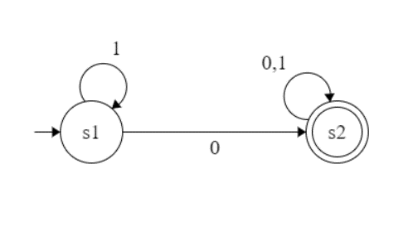

## **Perhatikan tabel transisi berikut ini :**

|  |  |  |
| --- | --- | --- |
| F | a | b |
| ->S0 | {S2} | {S0} |
| S1 | {S0} | {S0, S1} |
| *S2 | {S1} | {S2} |

1. Tentukanlah tupple dari tabel diatas (Q, ∑, T, S, F)

Q: {S0, S1, S2}

∑: {a, b}

T:

|  |  |  |
| --- | --- | --- |
| F | a | b |
| ->S0 | {S2} | {S0} |
| S1 | {S0} | {S0, S1} |
| *S2 | {S1} | {S2} |

S: S0

F: S2

1. Gambarkanlah mesin Non Deterministic Finite Automata (NDFA) dari tabel transisi diatas

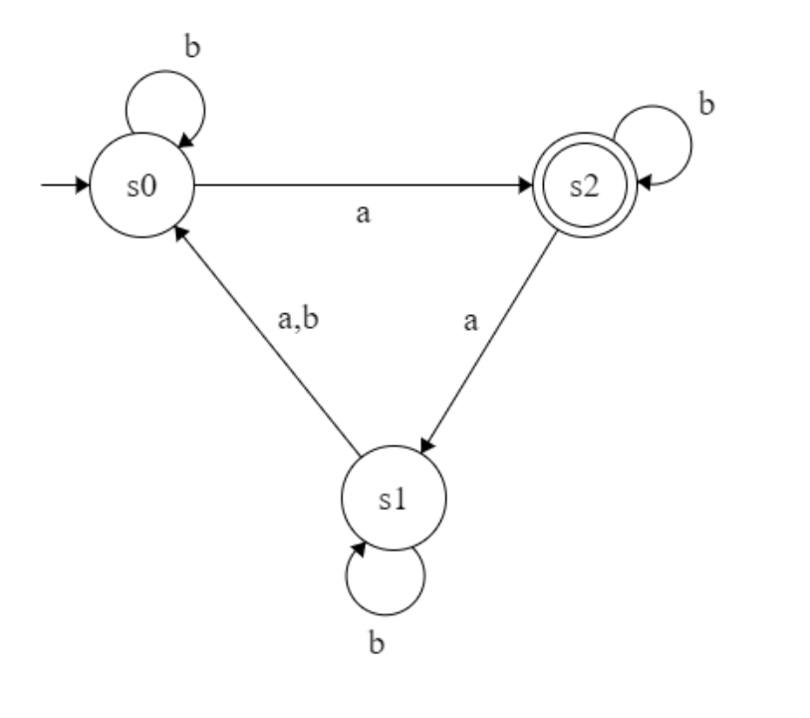

1. Konversilah NDFA diatas menjadi DFA dan tentukanlah masing-masing tupplenya (Q, ∑, T, S, F) yang baru d) Gambarkan DFA hasil konversi dari point C diatas

* Tuple
  + - Q: {S1, S2, S3, S4, S5, S6}
    - ∑: {a, b}
    - T:

|  |  |  |  |  |  |  |
| --- | --- | --- | --- | --- | --- | --- |
| F | a | b |  | F | a | b |
| ->S0 | {S2} | {S0} |  | ->S0 | {S2} | {S0} |
| S1 | {S0} | {S0, S1} |  | S1 | {S0} | {S3} |
| *S2 | {S1} | {S2} | -> | *S2 | {S1} | {S2} |
| {S0, S1} | {S0, S2} | {S0, S1} |  | S3 | {S4} | {S3} |
| *{S0, S2} | {S1, S2} | {S0, S2} |  | *S4 | {S5} | {S4} |
| *{S1, S2} | {S0, S1} | {S0, S1, S2} |  | *S5 | {S3} | {S6} |
| *{S0, S1, S2} | {S0, S1, S2} | {S0, S1, S2} |  | *S6 | {S6} | {S6} |

* + - S: S0
    - F: {S2, S4, S5, S6}
* Gambar

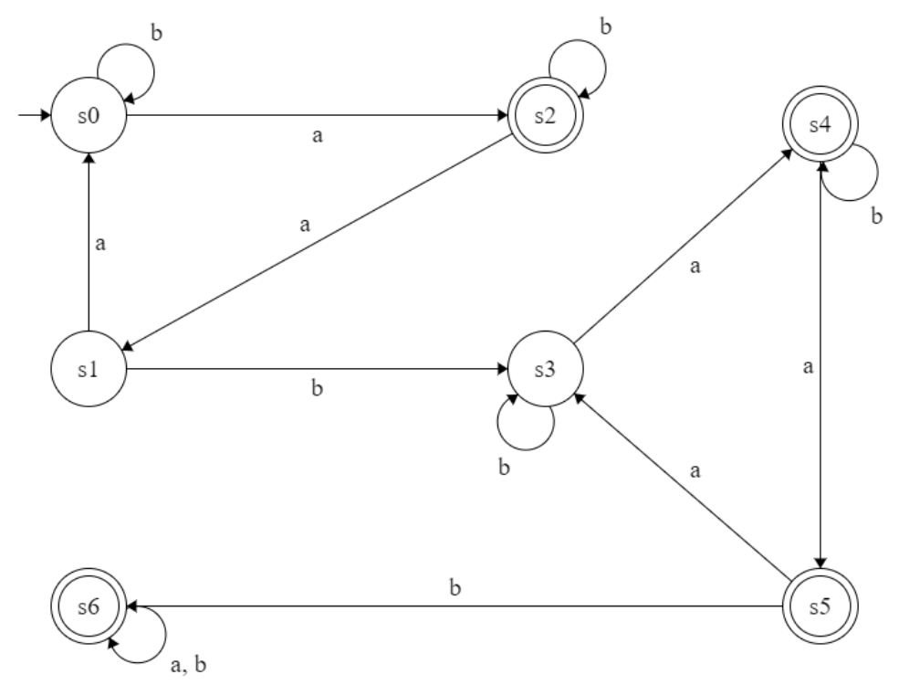

## **Perhatikan gambar berikut ini :**

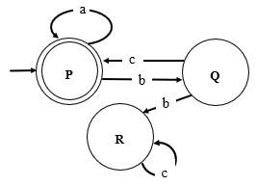

Tentukanlah :

* + 1. Semua Tupple dari gambar diatas (Q, ∑, T, S, F)

Q: {P, Q, R}

∑: {a, b, c}

T:

|  |  |  |  |
| --- | --- | --- | --- |
| T | a | b | c |
| ->*P | P | Q | ℇ |
| Q | ℇ | ℇ | C |
| R | ℇ | ℇ | R |

S:P

F:P

* + 1. T (P, aabcbcc) = (P, bcbcc) = (Q, cbcc) = (P, bcc) = (Q, cc) = (P, c) = ℇ Ditolak
    2. T (P,bcaabc) = (P, bcaabc) = (Q, caabc) = (P, aabc) = (P, bc) = (Q, c) = P Diterima

# **Soal UTS A2**

1. **Misalkan L1 dan L2 merupakan bahasa-bahasa berdasarkan alfabet ∑**

L1 = {1,3,5,7,9}

L2 = {1,2,3,4,5,6,7,8,9}

Tentukanlah:

1. L1.L2 c) L1 ∪ L2
2. L13 d) L1 ∩ L2

Jawaban:

1. **Perangkaian (Concatenation)**

**L1.L2**= {11, 12, 13, 14, 15, 16, 17, 18, 19, 31, 32, 33, 34, 35, 36, 37, 38, 39, 51, 52, 53, 54, 55, 56, 57, 58, 59, 71, 72, 73, 74, 75, 76, 77, 78, 79, 91, 92, 93, 94, 95, 96, 97, 98, 99}

1. **Eksponensiasi (Exponentiation)**

**L13**= **L11**= L1 = {1,3,5,7,9}

**L12**= L1 . L11= {11, 13, 15, 17, 19, 31, 33, 35, 37, 39, 51, 53, 55, 57, 59, 71, 73, 75, 77, 79, 91, 93, 95, 97, 99,}

**L13**= L1 . L12= {111, 113, 115, 117, 119, 131, 133, 135, 137, 139, 151, 153, 155, 157, 159, 171, 173, 175, 177, 179, 191, 193, 195, 197, 199, 311, 313, 315, 317, 319, 331, 333, 335, 337, 339, 351, 353, 355, 357, 359, 371, 373, 375, 377, 379, 391, 393, 395, 397, 399, 511, 513, 515, 517, 519, 531, 533, 535, 537, 539, 551, 553, 555, 557, 559, 571, 573, 575, 577, 579, 591, 593, 595, 597, 599, 711, 713, 715, 717, 719, 731, 733, 735, 737, 739, 751, 753, 755, 757, 759, 771, 773, 775, 777, 779, 791, 793, 795, 797, 799, 911, 913, 915, 917, 919, 931, 933, 935, 937, 939, 951, 953, 955, 957, 959, 971, 973, 975, 977, 979, 991, 993, 995, 997, 999}

1. **Gabungan (Union)**

**L1 ∪ L2** = {1,2,3,4,5,6,7,8,9}

1. **Irisan (Intersection)**

**L1 ∩ L2** = {1,3,5,7,9}

1. **Jika di ketahui string x = "hitam" dan y = "kotak", tentukanlah** 
   1. x|y = hitam atau kotak
   2. xy = hitamkotak
   3. |y|k = 2
   4. head(y) = k
   5. substring(y) = kotak, kota, otak, ak, ko, ot, ta, k, k, a, a, t, o dan ℇ
   6. prefix(y) = kotak, kota, kot, ko, k dan ℇ
2. **Buatlah sebuah DFA yang bisa menerima semua bahasa berikut dalam sebuah gambar dengan menggunakan 2 buah state** 
   * + - L(A) = {x | x = 01n0, x ∈ {0,1} }
       - L(A) = {x | x = 1m01n0, x ∈ {0,1} }
       - L(A) = {x | x = 001n, x ∈ {0,1} }



1. **Perhatikan tabel transisi berikut ini :**

|  |  |  |
| --- | --- | --- |
| F | 0 | 1 |
| ->a | {b} | {a, b} |
| b | {c} | {b} |
| *c | {a} | {c} |

Berdasarkan tabel diatas buat/tentukanlah :

* 1. Tentukanlah tupple dari tabel diatas (Q, ∑, T, S, F)

Q: {a, b, c}

∑: {0, 1}

T:

|  |  |  |
| --- | --- | --- |
| F | 0 | 1 |
| ->a | {b} | {a, b} |
| b | {c} | {b} |
| *c | {a} | {c} |

S: a

F: {c}

* 1. Gambarkanlah mesin Non Deterministic Finite Automata (NDFA) dari tabel transisi diatas

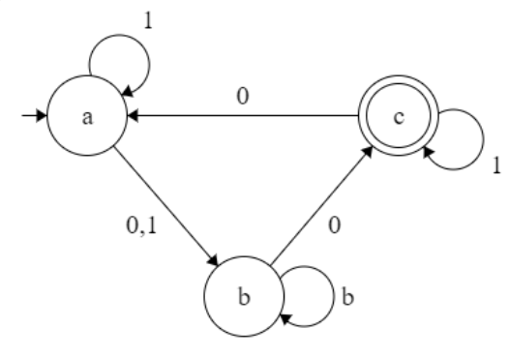

1

* 1. Konversilah NDFA diatas menjadi DFA dan tentukanlah masing-masing tupplenya (Q, ∑, T, S, F) yang baru

Q: {a, b, c, d, e, f, g}

∑: {0, 1}

T:

|  |  |  |  |  |  |  |
| --- | --- | --- | --- | --- | --- | --- |
| F | 0 | 1 |  | F | a | b |
| ->a | {b} | {a, b} |  | ->a | {b} | {d} |
| b | {c} | {b} |  | b | {c} | {b} |
| *c | {a} | {c} | -> | *c | {a} | {c} |
| {a, b} | {b, c} | {a, b} |  | d | {e} | {d} |
| *{b, c} | {a, c} | {b, c} |  | *e | {f} | {e} |
| *{a, c} | {a, b} | {a, b, c} |  | *f | {d} | {g} |
| *{a, b, c} | {a, b, c} | {a, b, c} |  | *g | {g} | {g} |

S: a

F{c, e, f, g}

* 1. Gambarkan DFA hasil konversi dari ***point C*** diatas

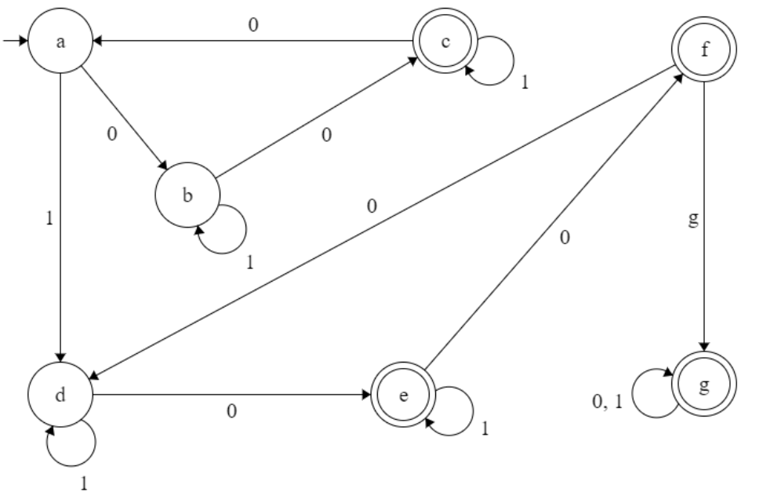

1. **Perhatikan gambar berikut ini :**

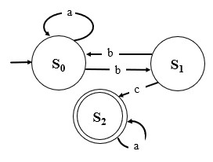

Tentukanlah :

* 1. Semua Tupple dari gambar diatas ((Q, ∑, T, S, F)

Q: {S0, S1, S2}

∑: {a, b, c}

T:

|  |  |  |  |
| --- | --- | --- | --- |
| T | a | b | c |
| ->S0 | S0 | S1 | ℇ |
| S1 | ℇ | ℇ | S2 |
| *S2 | S2 | ℇ | ℇ |

S:S0

F:S2

* 1. T(S0, aabbbca) = (S0, bbbca) = (S1, bbca) = (S0, bca) = (S1, ca) = (S2, a) = S2 Diterima
  2. T(S0, bbac) = (S1, bac) = (S0, ac) = (S0, c) = ℇ Ditolak